VIDEO - Financing Your Venture: Angel Investment - Negotiating the Deal

Financing Your Venture: Angel Investment - Negotiating the Deal
Video: https://www.youtube.com/watch?v=KsbS-R6HI04

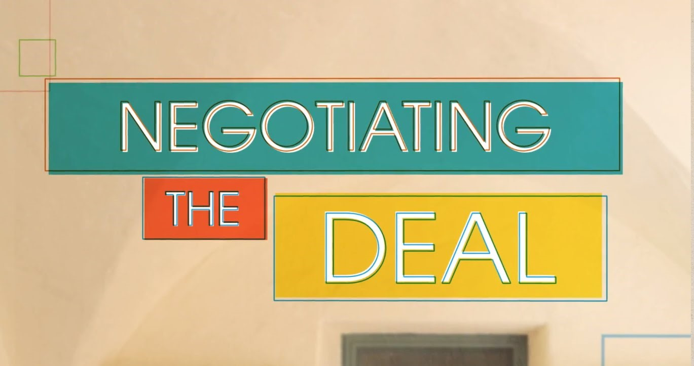

Description
Ian Sobieski, investor and managing director of the Band of Angels Venture Fund, highlights the benefits and specialties of angel investors, underlines the keys to finding and engaging an angel, and defines how to get the most out of your relationship with your investor after the deal is made.
ABOUT THE KAUFFMAN FOUNDERS SCHOOL
Visit the website: [http://bit.ly/1EW2br7]
The Kauffman Founders School presents a powerful curriculum for entrepreneurs who wish to learn anywhere, anytime. The online education platform features experts presenting lectures in series modules designed to give Founders a rich learning experience, while also engaging them in lessons that will make a difference in their business today, tomorrow, and in the future.
The Kauffman Founders School series modules include The Lean Approach, Intellectual Property, Founder's Dilemmas, Entrepreneurial Selling, Entrepreneurial Marketing, Surviving the Entrepreneurial Life, Startups, and much more.
©2015 Ewing Marion Kauffman Foundation. May not be used without permission. To enter a request for permission to use, contact FoundersSchool@kauffman.org.

Aus <https://www.youtube.com/watch?v=KsbS-R6HI04>

